IFT 266 Introduction to Network Information Communication Technology (ICT)
Lab 4
Basic configuration of a network switch

After you complete each step, put a ‘√’ or ‘x’ in the completed box

As you may remember from your days in IFT 259, you can have a managed switch that allows you to go into the switch & change/set settings i.e. program it to do certain things e.g. speed, duplex, VLANs, port security

On the other side of the coin, you can have an unmanaged switch. With this type of switch, you cannot configure anything inside of the switch. Plug it in and if it works great and if it doesn’t work then dump it.

During the course of IFT 358, you will in a sense be working with managed switches in Packet Tracer.


- Setup the following topology on Packet Tracer

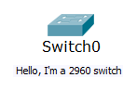

- Similar to Cisco routers, you can program the switch via the Cisco IOS (Internetwork Operating System). Cisco IOS is a proprietary operating system that runs on most Cisco Systems routers and switches. With this CLI operating system, you can change the configuration of the switch or router.
To enter the Cisco IOS on the switch, click on the switch and select the CLI tab and s prompted, hit return to get started.

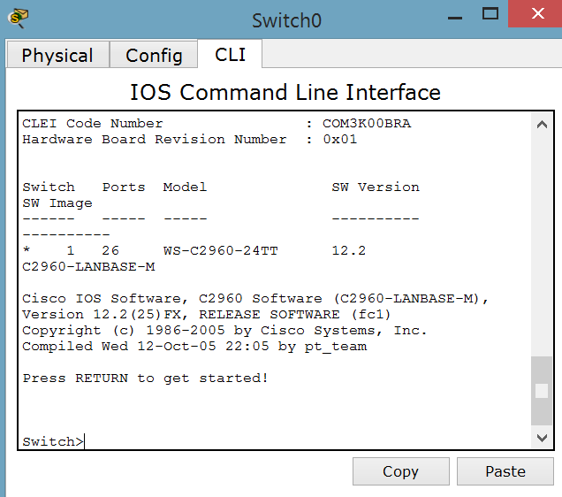
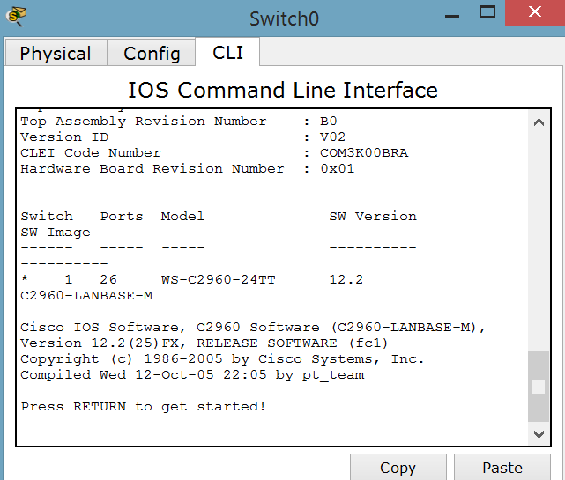

- Type the following commands into the switch. We will then explain what the commands actually do on the switch
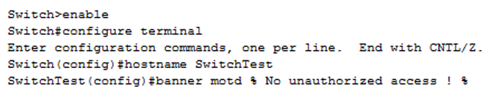

Similar to a router (you did a little bit of programming the router in IFT 259 and you will do lots more of it in IFT 489), switches have different modes or privilege level.

In each mode, we can perform certain tasks. The higher the mode, the more changes/configurations you can actually perform on the switch. There are ways to prevent unwanted individuals from making big changes to the switch i.e. use of passwords to prevent them from accessing certain modes.
Let’s look at the commands that we entered above.

You will see the prompt "Switch>".
This is the Initial Prompt → 1. Host name of switch followed by 2) > symbol
Default switch name → Switch>

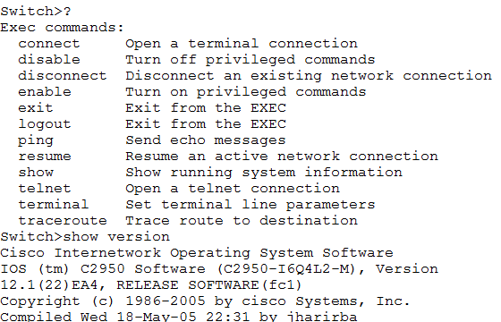
You are now in ‘User mode’ or ‘User Exec Mode’. User Mode is identified by the prompt >. User mode is like a view only mode. You cannot make any major configuration changes at this level or mode. You can run the ‘show version’ (as in the image below) which gives you details about the actual switch.

The command ‘Enable’ gets us into the Privileged Exec mode and then the command ‘configure terminal’ gets you into global configuration mode. Within enable mode or Privileged Exec Mode, you cannot do any real configuration on the switch.

To make some real changes on the switch you need to move up into global configuration mode typing in ‘configure terminal or config t’. With this operating system, you can abbreviate certain commands.

The hostname command allows us to change the name of the switch. In this example, the name of the switch changed to SwitchTest
The next command ‘banner motd’ displays a temporary notice to users, such no authorized access.

- We will now put in a password so I cannot get into this configuration mode.

There are two ways to achieve this and by typing enable ? You can see both of these two options below when I use the ?. The question mark allows you see what commands are available at certain modes

Password is rarely used as it does not encrypt the password (if you run the right show command then you could see the actual password) so we will use the secret option. You can choose a different if you wish (donkey is optional but highly recommended).

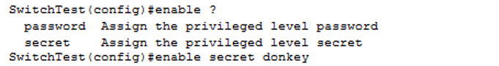

- A nice thing to know…..sometimes you will enter an incorrect command by mistake e.g. capy rather than copy

The following line of code will prevent you getting a timeout otherwise you will just have to wait it out for a minute or so)….

Alternatively, if you get this timeout then hit Ctrl + Shift + 6 on the keyboard

- We will now save the configuration (the new commands we entered which will change the configuration on the switch) from the running configuration file (stored on RAM, as we know RAM is volatile so it will not save the changes when it is turned off) to the startup file which is stored on NVRAM (RAM that constantly has power).

When you run this copy command, hit the return key to accept the default destination.

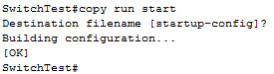

Make sure you save this file as will use it in the next lab!

